PAPER TEMPLATE AND INSTRUCTIONS FOR AUTHORS

Author #1a and Author #2b

a affiliation #1, including e-mail

b affiliation #2, including e-mail

Abstract

The *8th International Scientific Conference on Water* welcomes original research and review papers describing results of research, which are relevant to the Conference subjects. Please follow these guidelines carefully and note that this document follows the instructions given below, as an example.

Keywords: layout, typing instructions, references, nomenclature

Preparation of Manuscript

The language of the 8th ISCW is English, and the preferred spellings are those of the Oxford English Dictionary. The papers should be written in the third person in an objective, formal and impersonal style. SI units should be used wherever possible.

Manuscripts should be typed with single spacing in one column throughout the text (including references). The recommended text font is Times New Roman, size 10 pt. This document includes premade styles to help with formatting and consistency. **The suggested length of the manuscripts should be minimum 4 and maximum 8 pages!**

The preferred order of contents is as follows:

1. Title of paper
2. Author(s) name(s) and business address(es)
3. Abstract of not more than 250 words: covering the aims of the work, methods used, results obtained and conclusions reached
4. Keywords
5. Body of the paper – Introduction, Materials and methods, Results, Discussion, Conclusions
6. Acknowledgements (if necessary)
7. References – following the Harvard (with titles) reference style

**Tables**

Table captions are in upright type (font size 10 pt) and should be numbered consecutively throughout the text (e.g., "As illustrated in Table 4, the..."). Tables and their captions should be left justified.

Table 1. Paper size a

|  |  |  |
| --- | --- | --- |
| Type | Height [mm] | Width [mm] |
| A4 | 297 | 210 |
| A3 | 420 | 297 |
| A2 | 594 | 420 |

a Place table footnotes below the table and note them with superscript lowercase letters.

**Figures**

Illustrations have centered captions in italic type (font size 10 pt) and should also be numbered consecutively throughout the text (Figure 1). To ensure good quality of the proceedings book check the quality of graphics (minimum resolution of 300 dpi). Do not use too thin lines or too small fonts in your figures. Please make sure that the axes nomenclature in your figures is homogeneous and readable.

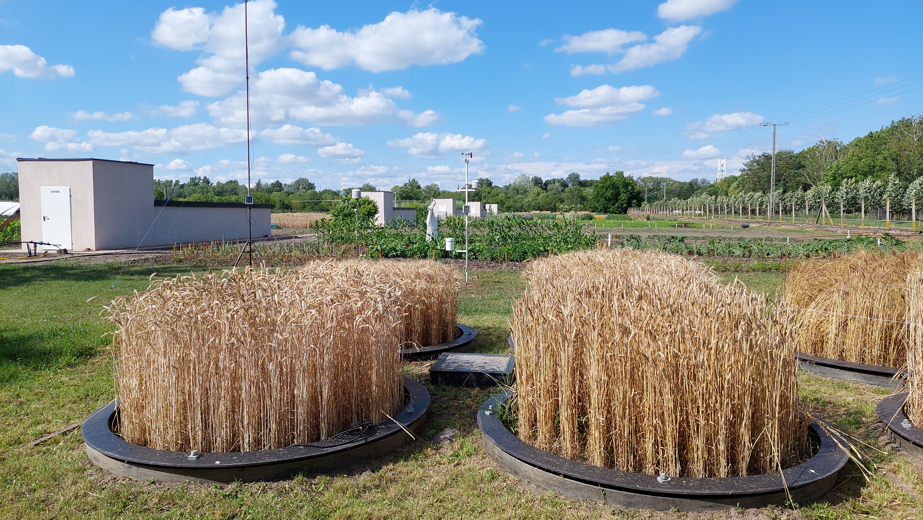

**Fig. 1.** Example figure layout

Submission of Manuscript – Review Process

**Papers must be sent in electronic form to the Conference Secretary: iscw.hu.** Each paper will undergo a thorough review by members of the Scientific Committee. Authors of papers that do not meet the required standards will receive detailed feedback and will be given an opportunity to upgrade their submissions. Only papers that meet the quality criteria after the review process will be accepted for presentation at the conference proceeding book.

**Copyright**

Papers are considered for publication on the understanding that they have not been submitted to any other Conference. The work described must be original and, generally speaking, not previously published. The copyright in papers accepted for publications becomes the property of the ISCW organizing committee to publish online in the conference proceeding book.

Acknowledgements

List here funding sources and those individuals who provided help during the research (e.g., providing language help, writing assistance or proof reading the article, etc.).

References

References should be followed the Harvard (with titles) reference style. References in the text should be indicated by author and date between parentheses (Bekker, 1960; Muroa et al., 1988) or “Sullivan and Anderson (2002) stated that …” Groups of references should be listed first alphabetically, then chronologically.

Koetz, B., Vekerdy, Z., Menenti, M., Fernández-Prieto, D. (Eds.), 2016. Earth Observation for Water Resource Management in Africa. MDPI. https://doi.org/10.3390/books978-3-03842-154-2

Kolozsvári, I., Kun, Á., Jancsó, M., Bozán, C., Gyuricza, C., 2022. Macro-, mesoelement and sodium content of plant parts of energy willows irrigated with effluent water of agricultural origin. COLUMELLA 9, 91–99. https://doi.org/10.18380/SZIE.COLUM.2022.9.2.91

Rolbiecki, S., Rolbiecki, R., Jagosz, B., Kasperska-Wołowicz, W., Kanecka-Geszke, E., Stachowski, P., Kocięcka, J., Bąk, B., 2023. Water Needs of Sweet Cherry Trees in the Light of Predicted Climate Warming in the Bydgoszcz Region, Poland. Atmosphere 14, 511. https://doi.org/10.3390/atmos14030511

Sauquet, E., van Meerveld, I., Gallart, F., Sefton, C., Parry, S., Gauster, T., Laaha, G., Alves, M.H., Arnaud, P., Banasik, K., Beaufort, A., Bezdan, A., Datry, T., De Girolamo, A.M., Dörflinger, G., Elçi, A., Engeland, K., Estrany, J., Fialho, A., Fortesa, J., Hakoun, V., Karagiozova, T., Kohnova, S., Kriauciuniene, J., Morais, M., Ninov, P., Osuch, M., Reis, E., Rutkowska, A., Stubbington, R., Tzoraki, O., Żelazny, M., 2020. A catalogue of European intermittent rivers and ephemeral streams. Zenodo. https://doi.org/10.5281/ZENODO.3763419

Şmuleac, L., Rujescu, C., Șmuleac, A., Imbrea, F., Radulov, I., Manea, D., Ienciu, A., Adamov, T., Pașcalău, R., 2020. Impact of Climate Change in the Banat Plain, Western Romania, on the Accessibility of Water for Crop Production in Agriculture. Agriculture 10, 437. https://doi.org/10.3390/agriculture10100437

Use of reference manager software is welcome to manage adequate references, but please unlink citations before submission to avoid unplanned changes in the text.